Robotics Technology for Physically abled warriors

* **Department of Computer Science And Engineering , Presidency University Bangalore***

**Abstract*--* The Earth consists of Seven billion people and not all people are born healthy and fit. Some people are born with physical disabilities which makes them difficult to move. It is very difficult to find a person to assist them all time. To overcome this difficulty wheelchairs using latest technologies have been developed in the past to overcome this problem but, completely paralyzed patients feel it difficult to use the technology of operating joystick, electro- myography, voice controlled wheelchair, etc. So to overcome the limitations of previously developed technologies, we have used EEG (Electroencephalogram) signals to control and operate the wheelchair. This technology is called brain computer interface (BCI) , where the human brain interacts with the computer to navigate the patient in particular direction. In this project eye blinking, meditation and attention levels are used to control the device as it generates significant pulse in EEG signals. The main objective of the project is to provide mobility for the completely paralyzed patients and to use the EEG signal to operate the wheelchair. This device allows the patient or the user to control the direction for six functions that is forward, backward, left, right, start and stop***.*

**Keywords:** BCI (Brain-Computer Interface), EEG(Electroencephalography)**.**

1. **INTRODUCTION**

The Human Brain consists of 100 billion neurons on an average scale. Electrical chargers are generated during its working. These electrical charges combine together to produce an electric field having varying potential in the order of microvolts. The electrical activity of the human brain can be taken from the scalp. These recordings taken from the scalp are known as Electroencephalogram(EEG). During EEG techniques electrodes are placed on the scalp of the person’s head to acquire signals which contains direct or indirect potential difference of scalp and the actions. The EEG signals are classified into the following bands: *α*, *β*, *δ*, *θ*, and *γ*. In the present scenario controlling various devices with the help of the brain is quite a wide field to research. In order to communicate and interact with computers using brainwaves we require an interface between brain and computer which is referred to as Brain-Computer Interface (BCI). The BCIs allow people to interact with other devices through their thoughts. The various

applications of BCI are brain controlled robotic arm, brain controlled keyboard etc. Out of all these applications, we will be focusing on the brain controlled wheelchair. BCI makes use of the EEG activity from the scalp to enable the users to control various devices. EEG based BCIs are being used for analysing several human activities including attention and meditation level with corresponding brain wave signals. Assistive control system and wheelchair have been designed for paralyzed and physically disabled patients. These actions are based on head movement and retina and ocular movement which makes use of accelerometer and image processing technique respectively. Moving head repeatedly is tiresome and not convenient for the patients as it causes fatigue. Whereas accelerometer cannot detect eye blink. Moreover, in image processing of ocular and retina movement a visible light source is mandatory to be present always near the eyes of the patient. This causes fatigue to the patient’s eye. In both of these techniques, while moving with wheelchair the patient cannot move his head and eye constantly. Using EEG signals according to attention and meditation level can solve these problems.

* 1. BRAINWAVE CLASSIFICATION

Based on frequency, brainwaves are classified into five bands as shown in

* Alpha Waves:The Alpha waves are said to be produced when a person is closing his/her eyes or is in a relaxed state. The frequency range of these waves is 8*Hz* to 12*Hz*.Alpha waves aid the state of meditation, calmness and learning and were first observed by Hans Berger.
* **Beta Waves:** The beta waves are generated when a person is in the state of alertness or engaged in some problem solving or is in the process of making any decision. The frequency range of beta waves is from 12*Hz* to 30*Hz*. Beta waves are further classified into three bands:

1. **Low Beta:** Its frequency range is from 12*Hz* to 15*Hz*. These waves are paramount in a relaxed yet focused state.
2. **Mid-range Beta:** Its frequency range is from 16*Hz* to 20*Hz*. These waves are generated when a person is engaged in a tough problem solving situation.
3. **High Beta:** Its frequency ranges from 21*Hz* to 30*Hz*. These waves are produced when a person is involved in dilemmatic situation.

* **Theta Waves:** Theta waves are produced when a person is in the state of deep meditation or is sleeping. These are low- frequency waves. Their frequency ranges from 4*Hz* to 7*Hz*. Theta waves are responsible for memory and intuition. Theta waves are also active during dreaming.
* **Delta Waves:** Delta waves are generated when a person is in a deep state of meditation or dreamless sleep. This state

stimulates healing and regeneration. These waves have frequencies ranging between 0*.*1*Hz* to 3*Hz*. These waves are slow but the loudest waves.

* **Gamma Waves:** These waves are generated during abnormal conditions or some mental disorder. These are the fastest brainwaves. These waves have frequencies greater than 30*Hz*.

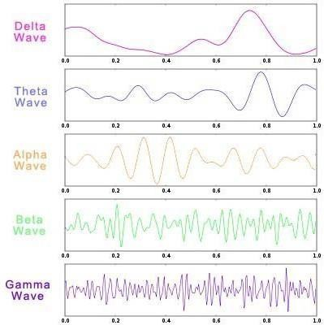

Figure -1- Classification of Waves

1. PROPOSED WORK

The key motivation behind this project is to aim to help people who are suffering from quadriplegia, paraplegia, people who met with accidents that left them with an extremity and people with any impairment in motor or sensory function of the extremities. So we came up with a project which helps these people to move without any muscle stress and that is the Brain controlled wheel chair, which uses EEG signals to move. In this project we also observed that it is somewhat difficult tocontrol the attention and meditation level of the brain leading to less accuracy of the system or higher deviation from ideal cases.So in our project we used eye-blink strength as a metric to control the movement of the wheelchair. The movement constraints are start, move forward, turn left, turn right and stop. Arduino software is used to write the instruction code of movement and IR sensor is used to detect obstacles in front. Bluetooth Module is also added to this system to allow easy transmission of data Along with it Wifi-module and Vibration sensor is added to the system in order to sense any signal when the patient gets dashed into an object and to message to their caretaker using Wifi- module.

1. SYSTEM REQUIREMENTS
   1. **HARDWARE DESCRIPTION**

NeuroSky**:** The NeuroSky device consists of a headset with an ear-clip and an arm which has a biosensor attached to it. It Contains a single-channel EEG electrode (sensor arm rests on the forehead, ground reference on the ear clip) which safely measures and outputs the EEG power spectrum (*α*, *β*, *δ*, *θ*, and *γ*). These EEG values are analysed at the ThinkGear chip to yield the attention/meditation and eyeblink level. Finally, these values are transferred wirelessly to Android/ Mac/ Windows etc. via Bluetooth. The device works on an AAA battery. This device also consists of built-in software/hardware for noise reduction.

**HC-05 Bluetooth Module:** HC-05 is a Bluetooth module which is used for wireless communication. This Bluetooth module can be used in a master or slave configuration. It uses IEEE802.15.1 standardized protocol, through which one can build Wireless Personal Area Network (PAN) and has a range of 10m to 100m. It communicates with micro-controller using serial port (USART). It has 6 pins namely Key/EN, VCC, GND, RXD, TXD and State.

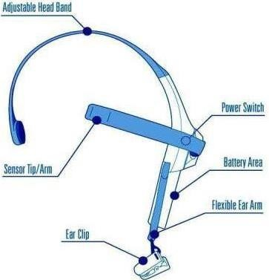

Figure-2- NeuroSky Headset

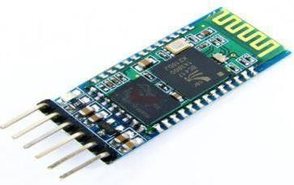

Figure-3- HC-05 Bluetooth Module

RF allowing it to work under all operating conditions, and requires no external RF parts.

Figure-4-Arduino Uno development board

**Arduino Uno:** Arduino Uno is the most commonly used Micro controllers. Uno is based on ATmega328p micro controller. It contains 14 input/output pins. It works with a Mini-B USB cable and can be operated by providing power via USB Mini-B or a 5*V* regulated supply.

**L298N Motor Driver:** Motor driver Module is a high power motor driver module for driving DC and Stepper Motors. This module consists of an L298 motor driver IC and a 78M05 5V regulator. L298N Module can control up to 4 DC motors, or 2 DC motors with directional and speed control. The L298N Motor Driver module 16 consists of an L298 Motor Driver IC, 78M05 Voltage Regulator, resistors, capacitor, Power LED, 5V jumper in an integrated circuit. 78M05 Voltage regulator will be enabled only when the jumper is placed. When the power supply is less than or equal to 12V, then the internal circuitry will be powered by the voltage regulator and the 5V pin can be used as an output pin to power the microcontroller. The jumper should not be placed when the power supply is greater than 12V and separate 5V should be given through 5V terminal to power the internal circuitry. ENA & ENB pins are speed control pins for Motor A and Motor B while IN1& IN2 and IN3 & IN4 are direction control pins for Motor A and Motor B.

**ESP8266 (Wifi Module**)**:** The ESP8266 Wifi Module is a self contained SOC with integrated TCP/IP protocol stack that can give any microcontroller access to your Wifi network. The ESP8266 is capable of either hosting an application or offloading all Wifi networking functions from another application processor. Each ESP8266 module comes pre- programmed with an AT command set firmware, meaning, you can simply hook this up to your Arduino device and get about as much Wifi-ability as a Wifi Shield offers. The ESP8266 module is an extremely cost effective board with a huge, and ever growing, community. This module has a powerful enough on-board processing and storage capability that allows it to be integrated with the sensors and other application specific devices through its GPIOs with minimal development up-front and minimal loading during runtime. Its high degree of on chip integration allows for minimal external circuitry, including the front-end module, is designed to occupy minimal PCB area. The ESP8266 supports APSD for VoIP applications and Bluetooth co-existence interfaces, it contains a self calibrated

**Motors:** A DC motor is any motor within a class of electrical machines whereby direct current electrical power is converted into mechanical power. Most often, this type of motor relies on forces that magnetic fields produce. Regardless of the type, DC motors have some kind of internal mechanism, which is electronic or electromechanical. In both cases, the direction of current flow in part of the motor is changed periodically. The speed of a DC motor is controlled using a variable supply voltage or by changing the strength of the current within its field Windrings, While, smaller DC motors are commonly used in the making of appliances, tools, toys, and automobile mechanisms, such as electric car seats, larger DC motors are used in hoists, elevators, and electric vehicles. A 12V DC Motor is small and inexpensive, yet powerful enough to be used for many applications. Because choosing the right DC motor for a specific application can be challenging, it is important to work with the right company.

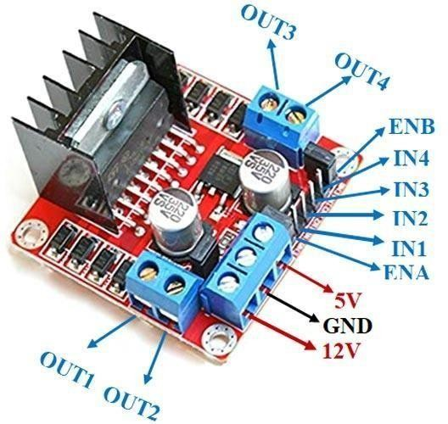

Figure -5- L298N Motor Driver

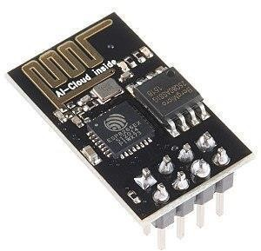

Figure -6- ESP8266(Wifi Module)

4. SYSTEM DESIGN

* 1. SOFTWARE REQUIREMENTS:

SOFTWARE USED: ARDUINO IDE LANGUAGE USED: EMBEDDED C

* + 1. ARDUINO SOFTWARE (IDE)

The Arduino integrated development environment - or Arduino software (IDE) - contains a text editor for writing code, a message area, a text console, a toolbar with buttons for common functions and a series of menus. It connects to the Arduino and Genuino hardware to upload programs and communicate with them.

* + 1. EMBEDDED C

The most popular embedded software language is Embedded C. It is the set of language extensions of c language to address

commonality between C extensions for different Embedded C. It requires nonstandard extensions to the C language in order to support exotic features such as fixed-point arithmetic, multiple distinct memory banks, and basic I/O operations.

The fact is that in embedded systems, there are many libraries that programmers have grown used to, but irregularly an embedded system might not have a complete standard library, if there is a standard library at all.

EMBEDDED SYSTEMS PROGRAMMING

Embedded systems programming is basically different from developing applications on a desktop computers. Key feature of an embedded system, when compared to pcs, are as follows: Embedded devices have resource limitations. In embedded system and pcs, the components are different. Embedded systems uses smaller, less power consuming components.

EMBEDDED SYSTEMS USING DIFFERENT TYPE OF LANGUAGES

* Machine code
* Low level language, i.e., Assembly
* Language like C, C++, Java, etc, i.e., High level
* Application level language like Visual basic, Access, Scripts, etc.
  1. WORKFLOW

The EEG Headset (NeuroSky Mindwave) detects and the EEG Signals from the brain and it is transmitted to the Bluetooth Module (HC-05) With a help of a in-built Bluetooth module named the Think Gear Chip. Then the Bluetooth Module transmits the signal to the Arduino board. The Arduino Board

Receives the Signal in the inform of EEG signals. Then the Arduino board instructs the Motor driver to Operate the motors in particular direction by following the instructions given from the user or the patient.

EEG

Headset

Think Gear Chip

Bluetooth Module

Interface

DC

Motors for wheel

Wifi- Module

Vibration sensor

Motor Driver

Figure-7-Hardware Connection Demonstration and Workflow

Arduino Board

The Vibration Sensor SW420 placed at the front of the model will detect any kind of Vibration or effect on the model, when the model gets hit into an object or any other foreign body. So, the vibration sensor detects the signal and following process now is continued by the Wifi Module ESP8266, which connected with Vibration sensor along with the Arduino Board. The Wifi Module sends an emergency message to the caretaker of the user or the patient through Telegram Mobile Application.

5 RESULTS & DISCUSSION

* 1. PARAMETERS

Three Parameters were designed to compare the Accuracy and design performance of the system. The combinations used are:

1. Attention level
2. Eye blink Strength
3. Meditation level

Attention: Attention is the cognitive process of concentrating on a particular information, whether subjective or objective, while ignoring other information.

Meditation: Meditation is a mental exercise or a technique which involves a conscious attempt to concentrate attention on some object of thought or awareness and prevents associative or ruminating thought processes.

Eye blink Strength: Eye blink is an involuntary blinking of the eyelids elicited when the cornea is simulated by touch, bright light, or other peripheral stimuli. The Strength of the response can be measured by electromyographic activity of the orbicularis muscle during eye blink.

* 1. EXPERIMENT RESULTS
     1. HARDWARE KIT IMAGE

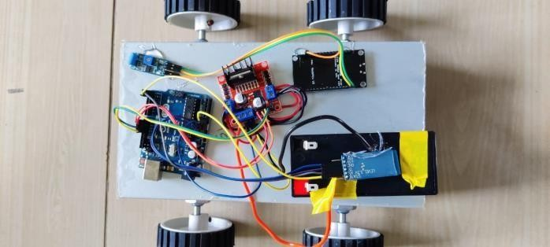

Figure -8- Hardware Kit Image

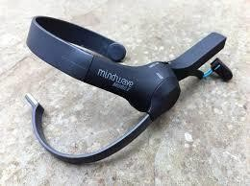

Figure -9- NeuroSky Headset

* + 1. EMERGENCY MESSAGE USING WIFIN MODULE

Figure-9-Emergency Message Using Wifi Module

1. CONCLUSION

A Smart Brain Computer Interface Based Miniature Wheelchair Using EEG Signals was developed. The system was tested for accuracy on three parameters. The patient will be able to move the chair in four direction namely North, South, East and West. The movements of the wheel chair is configured on the signals received by the headset. Eye blink strength is the most important and reliable parameter used to control the wheelchair since the attention and meditation values are not easy to control due to noise and other interference.

* 1. **LIMITATIONS**

The system suffers the following issue:

* This system cannot be used and should be avoided by people suffering from blink disorders, epilepsy, etc.
* It is not advised to use the system in public places like park, roads, etc due to sensitivity issues.
  1. FUTURE WORK

There are lot of improvements that can be made to this project to overcome its shortcomings and improve the systems confidence level in moving the miniature wheelchair smoothly as per the subjects will.

* Addition of Artificial Intelligence.
* Addition of Camera and security systems to protect the wheelchair from robust malwares and hackers.
* Scaling of the Acceleration and braking system.
* Smoothing in the change of directions.
* Increasing the sensitivity of the system to make it operational even at a low level of concentration/attention.

1. **REFERENCES**
2. Prashant Kumar Tiwari, Abhishek Choudhary, Saurabh Gupta, Joydip Dhar, Prasenjit Chanak, “Sensitive Brain- Computer Interface to help manoeuvre a Miniature Wheelchair using Electroencephalography”,in 2020 IEEE International Students' Conference on Electrical, Electronics and Computer Science, February ,2020.
3. Madhura B N, N Chandana, Navyashree M, “Brainwave controlled automated wheelchair “in 2020, NCDS 2020 Conference Proceedings.
4. Anjali Singh, Punija Choudhary, Shilpi Basuri, “Review on Brain Controlled wheelchair “in 2020, March, Volume 7, Issue 1, IJRAR.
5. Emani Susmitha, K.Kishore Kumar, “Design and simulation of brain controlled electronic wheelchair for physically challenged person”, in 2020, May, International Journal of Recent Technology and Engineering, Volume - 9, Issue-1.
6. Chaitra Rai, Manisha R, Priyanka C B, Syeda Saniya Anis, “EEG Controlled Smart Wheelchair for Disabled People“ , in NCRACES - 2019 Conference Proceeding, (Volume 7,Issue 10), June, 2019.
7. Md Fahim Ansari, Damodar Reddy Edla, Shubham Dodia “Brain-Computer Interface for wheelchair control operations: An approach based on Fast Fourier Transform and On-Line

Sequence Extreme Learning Machine” in 2019, Clinical Epidemiology and Global Health.

1. Antora Dev, Md. Asifur Rahman, and Nursadul Mamun, “Design of an EEG-based Brain Controlled Wheelchair for Quadriplegic Patients, in 2018 3rd International Conference for Convergence in Technology (I2CT), November, 2018.
2. Dorian Rotier, Xiadong Zhang, Qian Guo “Research on brain control Technology for Wheelchair”, in 2018, MATEC Web of Conferences, EITCE 2018.
3. Utkarsh Sinha, Priyanka Saxena, Kanthi M ”Mind Controlled Wheelchair” in May-June, 2017, IOSR Journal of Electrical and Electronics Engineering, Volume:12, Issue:3.
4. Ahmed Maksud, Rakibul Islam Chowdhury, Shaikh Anowarul Fattah, Celia Shahanaz, Sayeed Shafayet,“Low-cost EEG Based Electric Wheelchair with Advanced Control Features”, in TENCON 2017, November, 2017.
5. Rajeshree Mahendra Patil, Prof. D.M. Kate, Prof A.P Thakare, “Design and Implementation of Brain Computer Interface for Wheelchair control”, in International Research Journal of Engineering and Technology, (Volume 3, Issue 2), February, 2016.